Bonfield Public Library Policy Number: 2020-03 Policy Title: Reopening Plan Policy Approval Date: October 5, 2020 Policy Review Date: July 6, 2021
Purpose
This policy will establish a protocol for reopening the library which will be used in the event of an epidemic/pandemic or other public health emergency. The health and safety of our staff and patrons is our most important consideration as we resume library operations and services. The Bonfield Public Library Board will follow the lead of local health experts, municipal, provincial and federal authorities. In moving forward the library will continue to communicate and provide information on programming and outreach activities. This policy may require regular review and revision to ensure compliance with regulations set out by health and/or government officials.

Section 1: Access, Capacity and Requirements
The library will begin allowing five (5) patrons at a time to enter the physical library space to look for circulation materials for a period of 15 minutes, (not including staff). Once the library is at capacity, staff will inform patrons to line up outside the library and stay 2 metres (6 feet) apart until a spot opens up before entering the library. Signage will be posted for patron and staff safety conditions: social distancing requirements, hand sanitization, face masks requirements, patron self-screening questionnaire (See attachments)

Staff members are required to answer all Employee Covid-19 Self-Screening Questionnaire set out on the online government website: https://covid-19.ontario.ca/self-assessment before each shift; indicate their knowledge of an acceptable result from the questionnaire by printing the result page and inserting it in the Self-Screening Folder.
- All patrons and staff must wear a face mask (exemption Appendix “B”) for their own protection and that of others. Masks must cover their nose, mouth and chin during their visit to the library. Patrons who prefer not to wear a mask, use hand sanitizer or social distance, curb side pickup Is a great alternative.

- All patrons must use hand sanitizer upon entering the library, the Bonfield Public Library will provide hand sanitizer station at the entrance for the public.

- All patrons and staff will follow appropriate 6ft. (2m.) social distancing practices.

- Patrons who require a personal support worker or children (under 5 years old) with a parent/guardian will count as one (1) patron and will stay together within the library and practice social distancing from others.

- Curb side service will continue by appointment only via telephone 705-776-2396 or by email bonfieldlibrary@gmail.com

- Washrooms will be closed to the public.

- No food or drink may be brought in by patrons.

Page 1 of 4

Reopening/Procedure (continued)

Section 2: Internet and Computer Access
Patrons with their own devices may access the library Wi-Fi outside with no time restraint, by maintaining appropriate social distancing or in their own vehicles.
The library will provide two (2) desktop computers for public use within the library and one (1) Early Years Station. Due to social distancing restrictions, staff will not be permitted to provide one-on-one technology support during this phase of the reopening.
- Patron use of the desktop computer will be limited to one thirty (30) minute session daily.
- After each session, the computer and area will be cleaned prior to the next user.
- Patrons must book an appointment for each computer session to avoid crowding and wait times.
- Headphones will not be shared for public use. Patron will be required to bring their own, if they wish to use sound

Section 3: Interlibrary Loans/Donations

- We are accepting requests for interlibrary loans from our patrons and from other participating public libraries, but the current readiness of our lender libraries varies across Ontario. We cannot guarantee the order will be fulfilled.

- At this time we cannot accept book/items donations for the library.

Section 4: Check-outs and Returned Materials

Check outs:
- Items and materials will be checked out at the main circulation desk (through the Plexiglas)
- Patrons will be limited to check out a total of ten (10) books and three (3) DVD’s
- Patron’s reusable bags will be allowed.

Returned Materials:
- All books and items will be accepted for return through the external book return box and/or at the front desk.

Page 2 of 4

Reopening/Procedure (continued)

COVID-19 Disclaimer:
Although we strive to sanitize and practice safe handling of materials, The Bonfield Public Library cannot guarantee the sanitization of library items. Please handle them with caution.

- Patrons should wash hands before and after handling books and other items, avoid touching their face while reading and to avoid sneezing or coughing onto items.
- Patrons who are immune suppressed or otherwise susceptible to COVID-19 infection should not take out items from the library.
- Staff will continue to clean high touched areas after each shift.

Section 5: New Membership and Membership Renewal
- New patrons may come into the library and fill out a registration form and receive a library card.
- Non-resident ($25.00 pr/yr) fee will continue to apply.

.
Section 6: Shared Materials and Office Services

- All shared materials provided by the library, including but not limited to, pens, pencils, staplers, staple removers, hole punches, chargers, will not be available for patrons. Staff will be provided with their own personal supplies along with their own hand sanitizer.

- Photocopying, scanning, disc cleaning and faxing are available at the main circulation desk; fees will continue to apply.

Section 7: Hours of Operation

During this phase of the reopening, the Bonfield Public Library will have the following hours of operation and will be posted on the front door and on our website www.bonfieldpubliclibrary.ca

- Mondays 10:00am to 1:00pm
- Tuesdays 4:00pm to 7:00pm
- Wednesdays 4:00pm to 7:00pm
- Thursdays 4:00pm to 7:00pm
- Saturdays 10:00am to 1:00pm

Page 3 of 4

Reopening/Procedure (continued)

These hours are subject to change at the discretion of the Bonfield Public Library Board, in collaboration with the CEO and will be reviewed regularly during the changing circumstances of the epidemic/pandemic. At its discretion, the Bonfield Public Library Board may temporarily limit hours and/or services if there are insufficient staffs to maintain safe operations, cleanliness or to reduce the possible spread of the contagion. An increase in hours and services will be assessed going forward, on a regular basis, as regulations and requirements change.

If you have any questions or concerns, please email or call the library prior to your visit.
Phone: 705-776-2396
Email: bonfieldlibrary@gmail.com
Website : www.bonfieldpubliclibrary.ca

Thank you for helping us to contain the spread of COVID-19 and for supporting the Bonfield Public Library and the community of the Bonfield Township.

All businesses, organizations, and services are asked to continue to follow best practice for preventing the spread of
of COVID-19:
♣ Physically distance: To the fullest extent possible, ensure effective measures are in place to maintain physical
distancing amongst all persons who enter the premises.
♣ Promote hand hygiene: Practice cough and sneeze etiquette, encourage hand washing and make alcohol-based
hand sanitizer (with minimum alcohol concentration of 60%) available at all entrances and exits.
♣ Wear face coverings
2
: To the fullest extent possible and when physical distancing is challenging or not possible,
ensure all persons wear a face covering.
Dedicate specific hours for customers who are at high risk such as seniors, people with disabilities, or those who are immunocompromisedAll businesses, organizations, and services are asked to continue to follow best practice for preventing the spread of
of COVID-19:
♣ Physically distance: To the fullest extent possible, ensure effective measures are in place to maintain physical
distancing amongst all persons who enter the premises.
♣ Promote hand hygiene: Practice cough and sneeze etiquette, encourage hand washing and make alcohol-based
hand sanitizer (with minimum alcohol concentration of 60%) available at all entrances and exits.
♣ Wear face coverings
2
: To the fullest extent possible and when physical distancing is challenging or not possible,
ensure all persons wear a face covering.
All businesses, organizations, and services are asked to continue to follow best practice for preventing the spread of
of COVID-19:
♣ Physically distance: To the fullest extent possible, ensure effective measures are in place to maintain physical
distancing amongst all persons who enter the premises.
♣ Promote hand hygiene: Practice cough and sneeze etiquette, encourage hand washing and make alcohol-based
hand sanitizer (with minimum alcohol concentration of 60%) available at all entrances and exits.
♣ Wear face coverings
2
: To the fullest extent possible and when physical distancing is challenging or not possible,
ensure all persons wear a face covering

Page 4 of 4

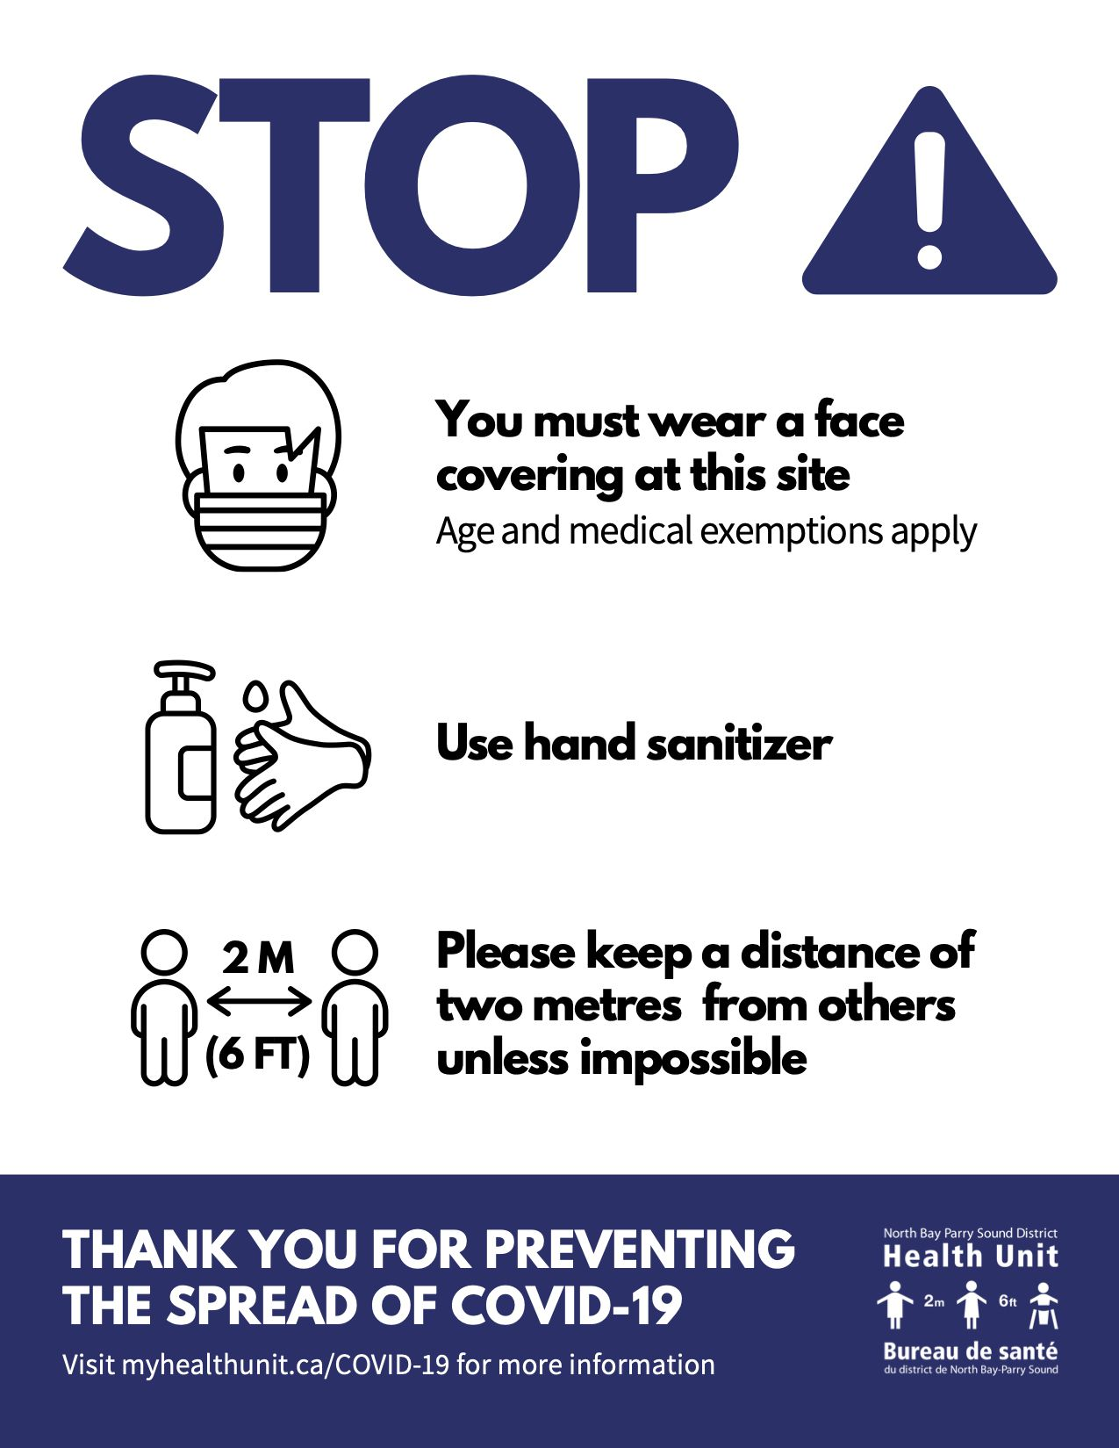

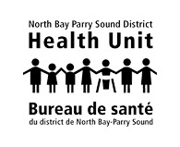

Who is exempt from wearing a face covering?

Exemptions are in effect for multiple reasons, including medical and age-related. No proof is required. The goal is to ensure the best protection possible (including for those who cannot wear face coverings) until a vaccine or specific treatment is available.
The following persons are exempt from wearing a face covering:
- children under the age of two years; or children under the age of five years either by birth age or mental development who refuse to wear a face covering and cannot be persuaded to do so by their caregiver;
- persons who are unable to remove their face covering without assistance under the Accessibility for Ontarians with Disabilities Act (AODA) or who have protections under the Ontario Human Rights Code, R.S.O 1990, c.H.19, as amended;
- persons whose breathing would be inhibited by wearing a face covering;
- persons with medical conditions rendering them unable to safely wear a face covering (including but not limited to: respiratory disease, cognitive difficulties or difficulties in hearing or processing information);
- officiants (e.g. minister, rabbi, priest, imam) of a religious ceremony if standing in an area of the worship space that is separate and at least two metres apart from the public attending the ceremony;
- a person who is employed by or is owner/operator of an enclosed public space and:
  - in an area that is not designated for public access and where physical distancing of two metres can be maintained;
  - within or performing duties behind, a physical barrier (e.g. plexiglass barrier); however, staff must wear a face covering in a situation where physical distancing cannot be maintained with other staff within or behind a physical barrier, or
  - in an office that is not open to the public including professional offices where clients receive services by appointment only (e.g. lawyer, accountant) – except waiting room, as applicable.
- a person who is employed in a space subject to provincial and/or local public health guidance, including:
  - child care centres and providers governed by the Child Care and Early Years Act, 2014, S.O. 2014, c. 11, as amended (except when medical masks are required, as directed);
  - day camps; and
  - schools under the Education Act, R.S.O. 1990, c. E.2, as amended.
*Parents / guardians are required to wear a face covering when entering a common area of these premises.
There may be situations where someone who is deaf or hard of hearing may require a staff member to remove their face covering to speak to them. We remind anyone removing their face covering to follow safe handling procedures (see 6h) below) and to keep a physical distance of two metres away from others.

Information on the mandatory use of a face covering
There is a local and provincial face covering mandate in place and the information below captures what needs to be followed by residents and businesses in the district of North Bay Parry Sound.
*In the event of differences between the instruction provided by the Medical Officer of Health, persuant to O. Reg. 364/20 Sched. 1 s2(2) (or as current) and another Act, regulation or by-law related to face-coverings in public spaces, the guidelines that are the most restrictive and strict should be followed.

If you answer YES to any one of the questions below,
PLEASE DO NOT enter this location
AND contact either your health care provider or Telehealth Ontario (1-866-797-0000) to get advice or an assessment, including if you need a COVID-19 test.
